Family and Friends Support Group  A coffee and conversation group for family and friends of gay, lesbian, bisexual, transgender and questioning children and youth. Please join us to meet and build community with other families. | 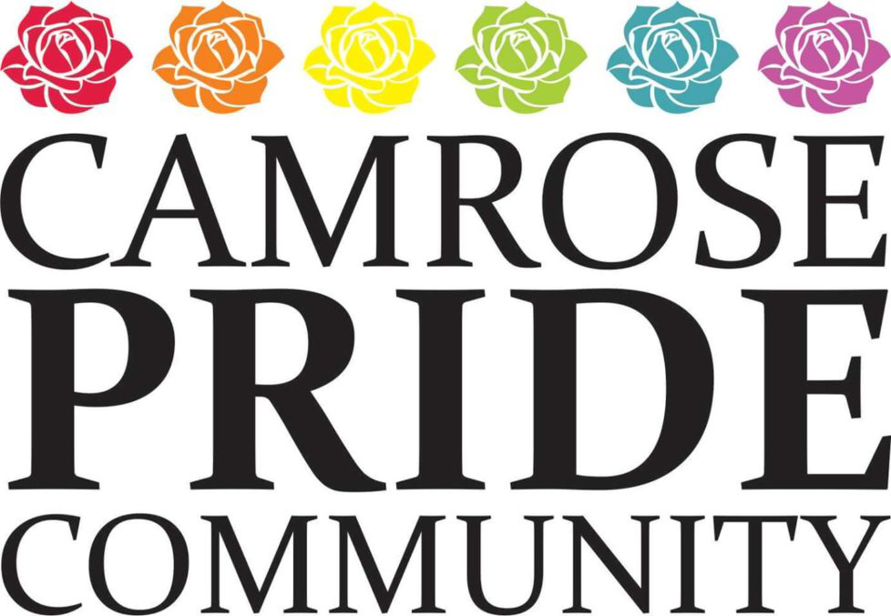  Where: Camrose United Church – lower parlour  When:  7-9pm Monday February 13  March 13  April 10  May 8  June 12  We will provide coffee, tea and some light refreshments  Come and join us for a chance to  talk and share stories.  For more info contact: jen@altview.ca

